Non-Contact Detection of Glucose Concentration – Monte Carlo Simulation

R.Davis

**Abstract**

Diabetics have a problem with their metabolism and bodily functions due to glucose concentration being either below the necessity, or the body is unable to process all of the sugar it produces. As a result, they constantly have to monitor their glucose levels to see if they are at the appropriate levels for their body. Currently the most effective method that exists utilizes invasive means, by pricking themselves and checking those levels. The purpose of this study is to explore a non-invasive method using the Electric field Monte Carlo simulation, which would use polarized light as it passes through a magnetic field to observe the Coherent Backscattering factor and how it varies under different conditions and concentrations of the glucose solution.

**Background**

Glucose is considered an important molecule to the metabolism of the human body. In the body’s metabolic system, it is the primary way to transport carbohydrates as well as other fuels to the cells which require it to function. However, there exists a group people labeled as, diabetes mellitus, in which either the diabetic does not produce enough sugar, Type I, or the cells do not respond to the insulin which is produced, Type II. As a result of this lack of production or lack of responsivity diabetics have to constantly monitor their sugar levels to ensure that their metabolisms are functioning properly.

Type I diabetes is normally formed at birth; it is also called the juvenile diabetes. On the other hand, Type II diabetes develops based on life style after a certain age. This diseases, Type II, constitutes for about 95% of the diabetic population. In the United States alone, there is an expectancy of about 29 million of the population which are currently diagnosed with diabetes. That is roughly about 9.3% of the population.

The problem which the diabetic is, is that to monitor their glucose levels they have to do that via invasive means. This implies a prick to the finger to draw blood, and using a test strip check the flux to monitor their blood levels. As a result of this researchers have been focused on finding other non-invasive means, ones which would not penetrate the skin and can be done outside of the body. Some current methods which do not include bodily penetration to name a few include: photoacoustic spectroscopy, optical coherence and como glucometer.

In photoacoustic spectroscopy, optical light is converted to an acoustic energy through a multi stage converter which utilizes a piezoelectric detector. By measuring the change in concentration, researchers were able to detect a change in photoacoustic pulse. The problem with this method however, is that it is very sensitive to the outside sounds which might interfere with it. Another possible solution includes, optical coherence tomography or OCT. The OCT device utilizes a light that is aimed at the patient which then backscatters from structures within the tissue. In doing so the scattering coefficient will change based on the concentration of glucose inside the body. Also, an extracellular glucose will increase the refractive index of the substance. Lastly, we can account for como glucometer which utilizes the absorption band of glucose to detect how much of light emitted from the device will be absorbed into the body and calculates the concentration that way. The problem with these methods is that there are too many parameters to isolate for to ensure proper readings when performing them.

In this study, we want to take a look however at the three main optical methods and simulate one of them to measure blood glucose concentration. In optics there are three main methods for detecting optically: absorption, scattering and polarization.

In absorption, like in the como glucometer, light is emitted into the body. Based on the absorbance band of regular concentration of glucose versus a diabetic which can be observed less, we can utilize the light to detect the concentration inside the body. Below is an image which shows the absorption band for glucose.



In scattering, we utilize a laser that creates a speckle field. This speckle field’s intensity is then measured and we can determine the concentration of glucose in that manner. It utilizes the magneto optic effect in combination with the Faraday Effect to generate the speckle field based on the rotation of light. The image below shows how a setup like that might look like.

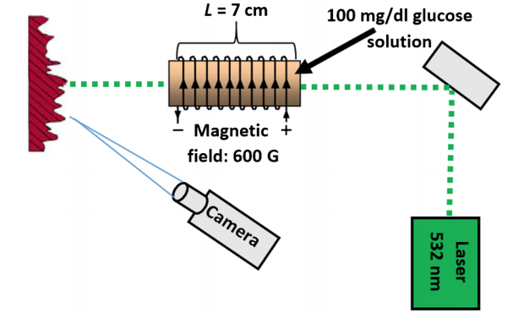

Finally, we utilize polarization which detects the change in the rotation of light through a turbid medium and measures the output intensity of light. This differs from the scattering because no more are you producing a speckle field but a steady stream of light. Below is an image of that experimental setup. Where P1 and P2 are the polarizers which the light passes through.

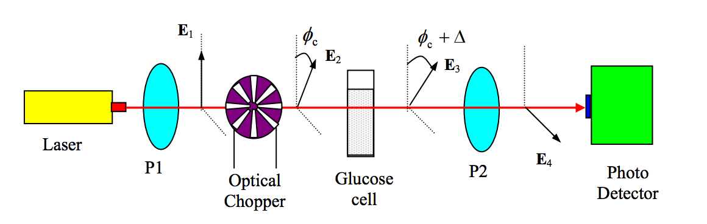

**Motivation**

The problem with present methods however is that they: lack accuracy, are un-reliable, ultra-sensitive to changes, do not have fast response and there is a high cost per unit to perform. Our study, implements the electric field in a Monte Carlo code, to study the light backscattering from a glucose suspension with the presence of the magnetic field. During this study we simulate the experiment utilizing a Monte Carlo Simulation and find the effect of the Faraday rotation on the Coherent Backscattering effect (CBS).

**Electric Field Monte Carlo Simulation - Coherent Light Backscattering from a Glucose Solution**

The Monte Carlo simulation is a broad class of computational algorithms that rely on repeated sampling to obtain numerical results. The idea behind them is to utilize randomness to solve problems which are deterministic in nature. The electric field Monte Carlo (EMC) is just one type of special simulation that the Monte Carlo simulation utilizes.

Upon each scattering event we can trace the electric field that is produced both in the parallel and the perpendicular direction. That electric field effect the rotation of the photon that passes through onto the next event until it finally reaches out of the turbid medium.

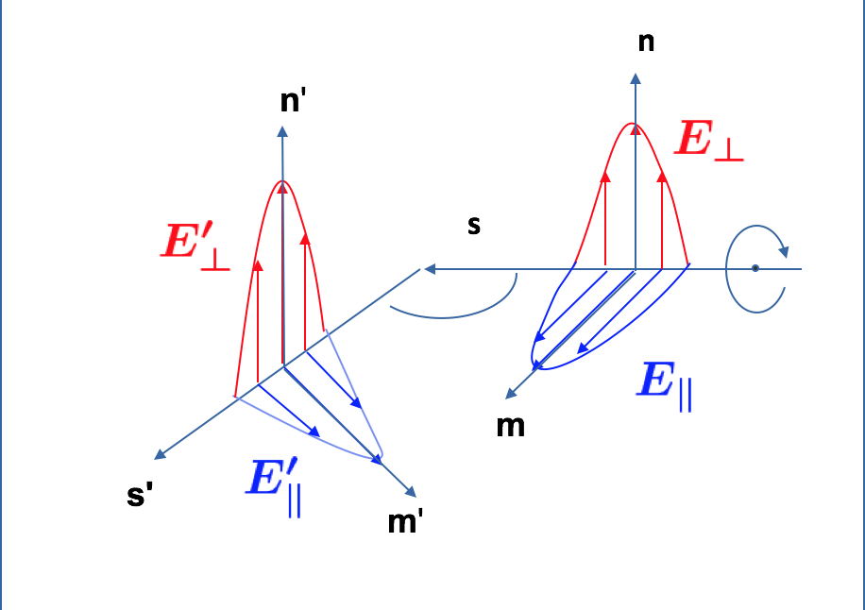

The figure depicted above show how the magnetic field is traced upon each scattering event. Each event is then governed by the following equation:

Where E is the present electric field, R is the rotation matrix between the incoming and outgoing perpendicular electric fields and S is the scattering matrix dependent on the scattering angle between the incoming propagation direction and outgoing propagation direction. This can be further show as a matrix, which is what was used in the computation:

Where E1 and E2 are respectively the complex parallel and complex perpendicular fields.

In our experiment we utilize CBS to perform these simulations. CBS occurs when light propagates through turbid substances such as glucose solution, since it contains many scatters and detecting the intensity is easier since it is twice as high as standard coherent radiation. As a result, weak localization can be detected since it is manifested as an enhancement of light intensity in the backscattering direction.

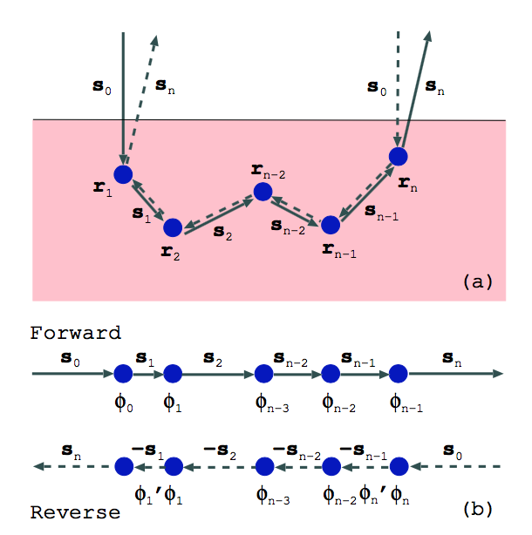

The figure above describes how the light propagates through the turbid medium where rn is the scatter and sn is the distance traveled from one scattering point to another. At each point the light will create an electric field in both parallel and perpendicular directions which it rotates the light scattering. However, in the figure above, there is no magnetic field present so upon entry the light just goes straight in and exits on an angle. Yet, in our study we introduced a magnetic field over the turbid medium, so upon entry the light would enter with a pre-existing rotation. By incorporating the Faraday rotation, we also introduce an extra rotation inside the medium, since no more is the light rotating just due to the scattering events. The figure below shows how the setup of this experiment changes.

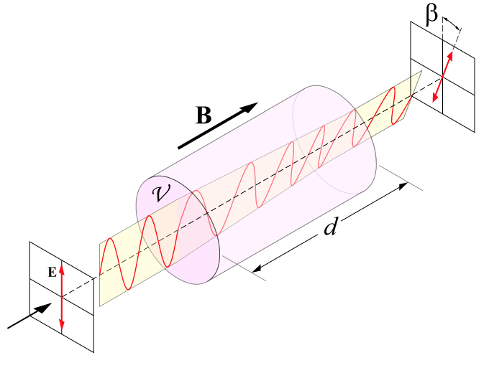

However, this extra rotation is dependent on the concentration of the glucose and is described by this equation:

Where is the Verdet constant which is 3.94 rad/m * Tesla for glucose. In comparison, the Verdet constant for water is about 3.81 rad/m * Tesla. B is the magnetic field present and is the distance traveled by each scattering event.

If we take a look at the previous equation which describes the rotation of the light inside glucose without the presence of a magnetic field we notice that R is described in the following manner:

However, with the introduction of the magnetic field the equation slightly changes. We are now introducing an extra rotation which can be described by:

As a result of this addition the total rotation of the light is described by:

Which becomes:

Where the is described in components like this:

The reason it is split into component is because when writing the code out you have to be able to differentiate in which direction the photon is going and where you are applying the magnetic field.

Prior to the introduction of the Faraday effect our equations to describe each scattering event can be summed up like this:

Forward Path:



Reverse Path:



After the introduction of the Faraday effect we get the following:

Forward Path:



Reverse Path:



Noticing the subtle differences is important since prior to the Faraday effect the same equation can be used to perform the calculations but in the reverse order. However, with the introduction of the extra rotation, both the forward and reverse direction will change since no more is the photon entering on a straight angle in both instances.

Now, observing the function inside the code we will see how we implement the Faraday rotation to perform the calculations. Below is an image of the code:

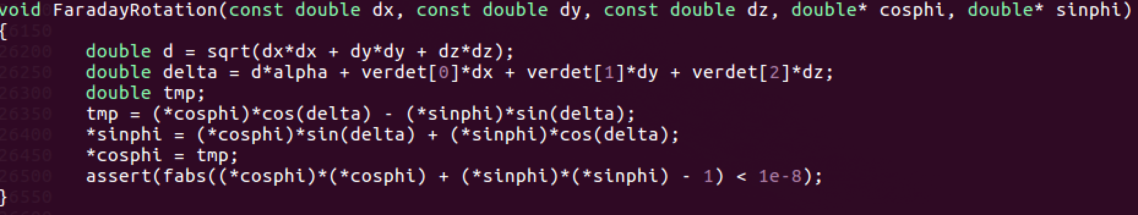

As previously mentioned, the extra rotation angle had to be expanded into components. This is done to better accommodate for how the code functions and how it cannot perform a calculation on all three since the compiler cannot interpret that sort of math in C/C++.

Upon introduction of the Faraday effect we also have to alter the presence of the Faraday rotation upon each scattering point. Previously the code only accommodated for two separate rotations, however, since we introduced the magnetic field, in every instance that occurs we also have to introduce that magnetic field rotation. This can be seen in the image below:

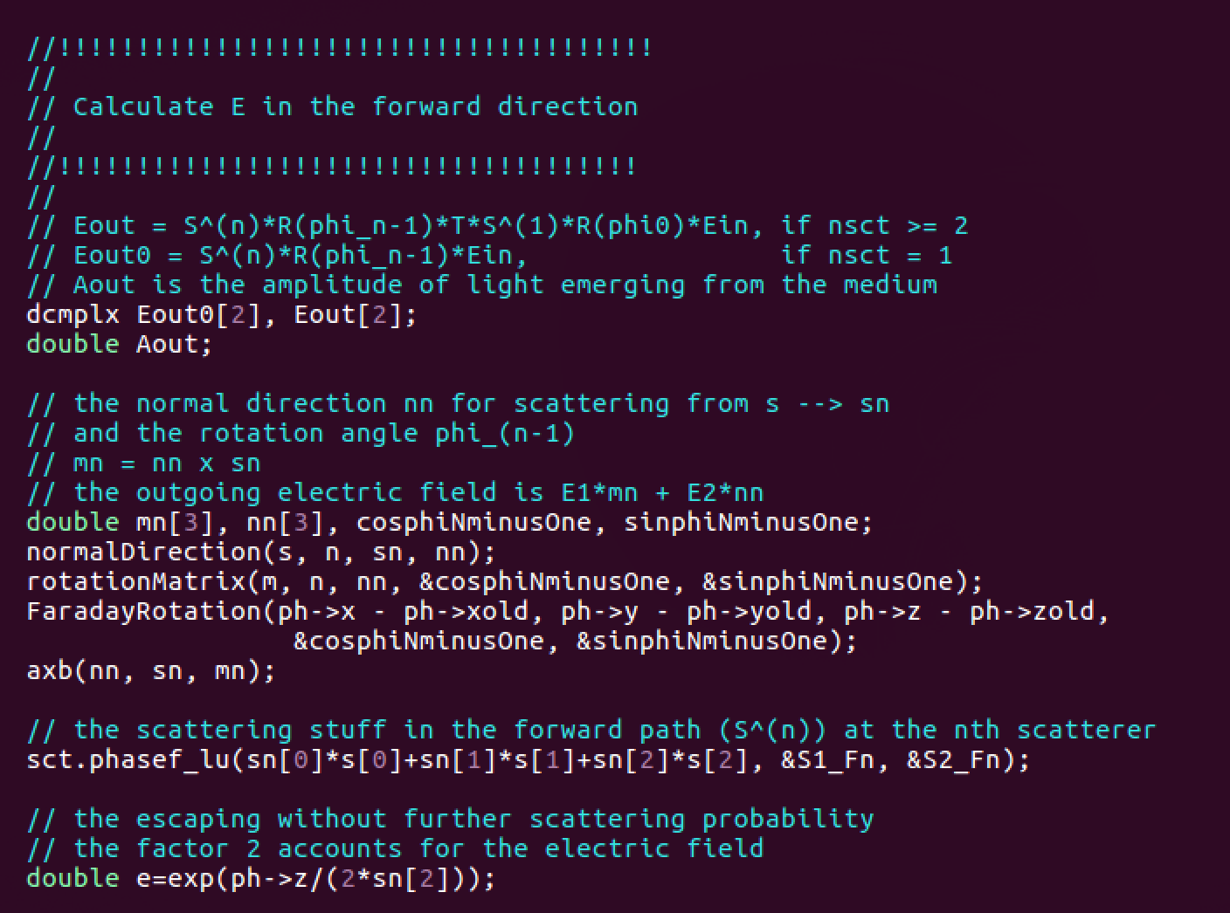

Depending on the amount of photons present as well as the amount of thetas you would like to explode the code could potentially run for up to two to three days using a single core to process the information.

**Results**

When observing the results, we explored a varying Verdet constant in the x-direction of magnetic field propagation and what occurs the more you increase it what happens to the CBS Factor. As previously mentioned, one literature value for the Verdet constant was 3.94 . If we convert that to how our Faraday rotation function works that value becomes 0.0039 rad. This produces a factor of 1.674. In comparison when there is no magnetic field present, that same factor is 1.677, which is a 0.2% difference. Below is the figure showing the results from that experiment as well as a comparison what would happen if we doubled the magnetic field. The results below are simulated at both 1 Tesla, the blue line and at 2 Tesla the orange line.

Since the result above was for a broader range of Verdet constants, we also explored what the graph would look like had we just focused in on the range of 0 to 0.1. The figure below describes that:

We also tried using circular polarized light to determine if the backscattering factor would vary. However, circular polarized light with a magnetic field applied in the x-direction did not net any better results. With the value of the backscattering coefficient actually starting off at 1.675, which is significantly enough lower where the detection of the glucose concentration would be harder.

Since this is a study of a Monte Carlos simulation on non-invasive glucose detection it would be important to also discuss about the setup of the actual experiment and how it would look like. The figure below shows that light source would be present and light would be launched at the turbid medium through a polarizer as well the magnetic field in the x-direction. At which point when it exits we can detect the CBS effect with a detector. Based on the current results the more detection that is occurring the better, since the margin to capture that slight variance is so small.

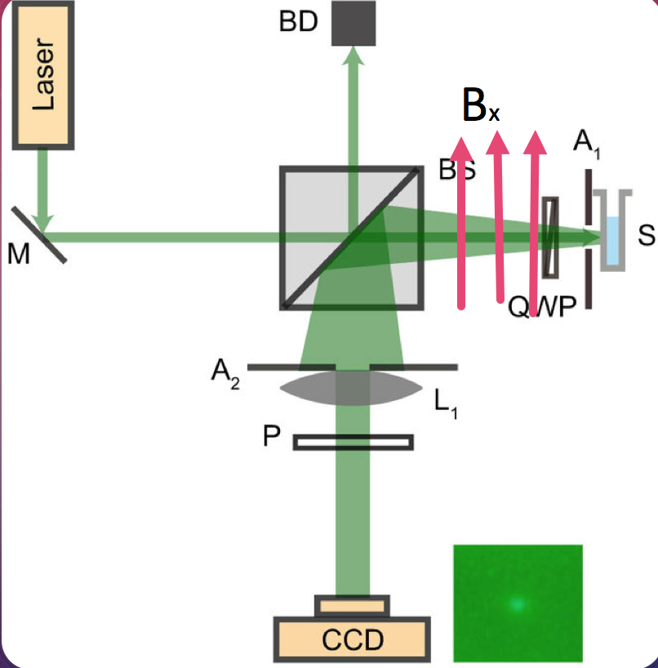

**Conclusion**

As a result of this study a few important things were accomplished. We were able to successfully simulate CBS in a glucose solution using the Monte Carlo Simulation method. We introduced a magnetic field to see how it affected the CBS factor and whether it would improve detection on the glucose. Due to the small variance between a magnetic field and lack of magnetic field, to improve the experiment would have to first perform it physically. Then, be able to determine whether increasing the magnetic field to a higher value other than the one performed in this experiment would net better results for detection.